Name: Kurt Gabriel A. Anduque

Section: BSCPE21S1

**Problem 1: (Infinite Algorithm)** The problem with this algorithm is that, some of the steps appear more than once, i.e. step 5 get second number, step 7, get third number, etc. One could shorten the algorithm or flowchart as follows:

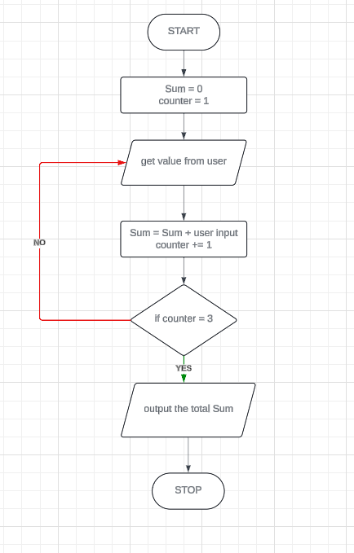

**Problem 2: (Finite Algorithm)** The new list of numbers is given as 26, 49, 498, 9387, 48962, 1, -1. The value –1 is a unique number since all other numbers are positive. This means that the procedure will stop once -1 is encountered.

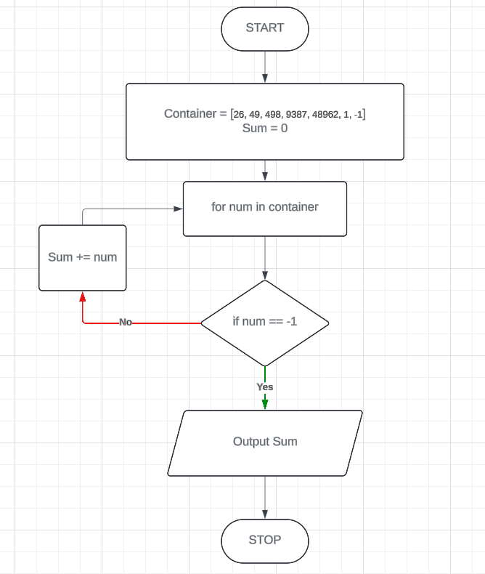

3. Design an algorithm and the corresponding flowchart for finding the sum of the numbers 2, 4, 6, 8, …, n (output: Algorithm and Flowchart)  
  


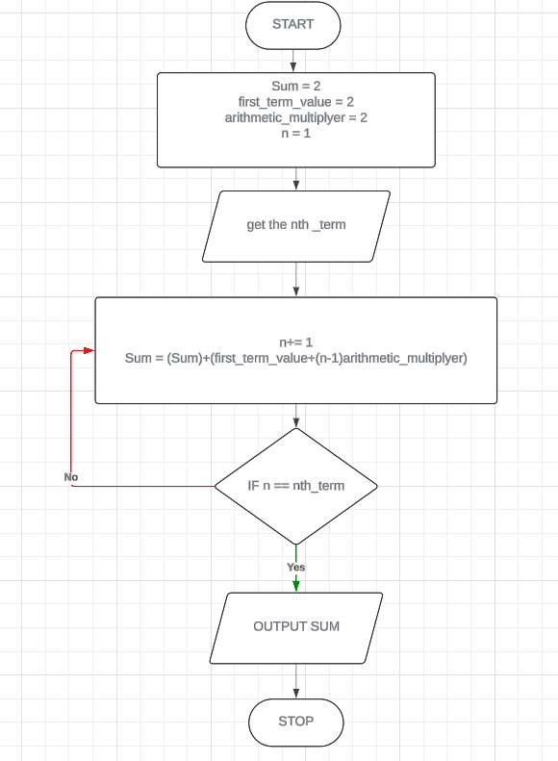

4. Write an algorithm to read 100 numbers and then display the sum.

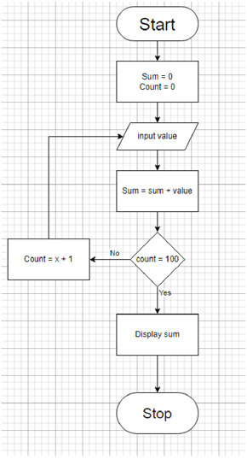

5. Write an algorithm to read two numbers then display the largest.

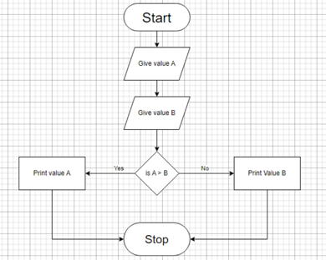

6. Write an algorithm to read two numbers then display the smallest

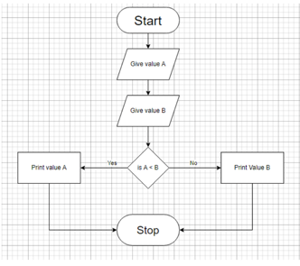

7. Write an algorithm to read three numbers then display the largest.

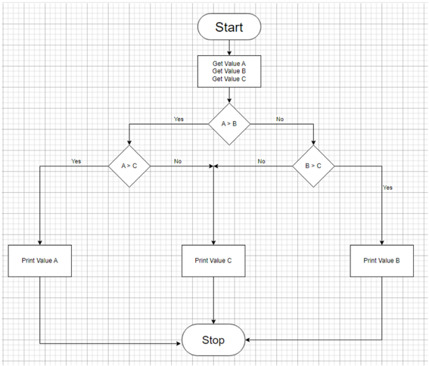

8. Write an algorithm to read 100 numbers then display the largest.

